Pranav Joseph Tossy: **B00158966**

Jithin Jelson: **B00143661**

Ojal Rakwal:  **B00160822**

Git: https://github.com/pranavjosephtossy/SP_Prj.git

JITHIN:

Access Control Vulnerability was found as within the sitemap in the page source there is a link to the admin panel

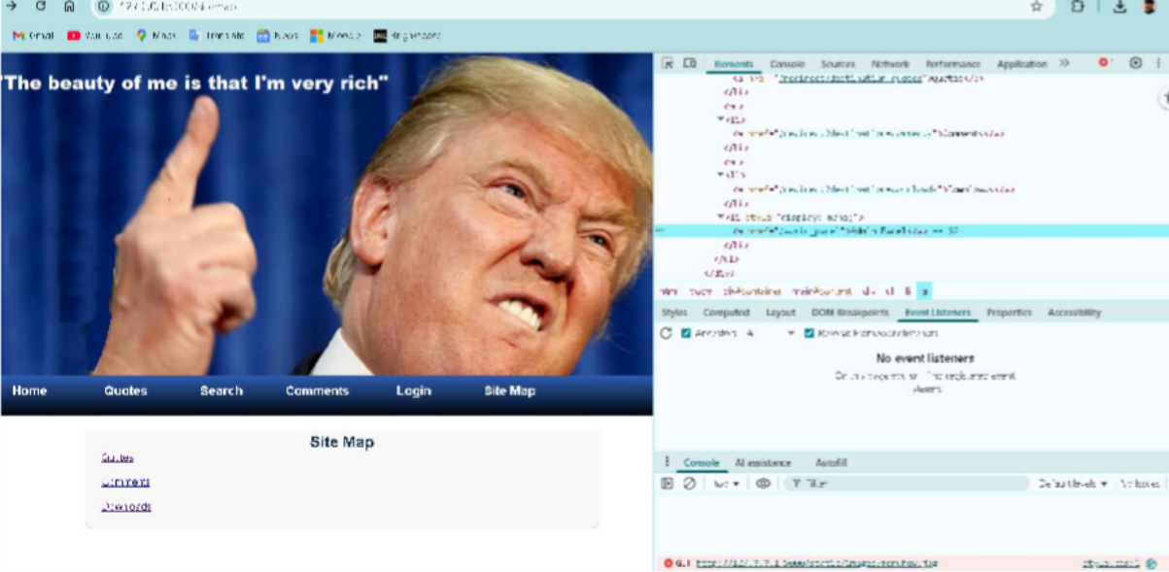

When clicked on, the admin panel is displayed and there is no proper authorisation or authentication checks

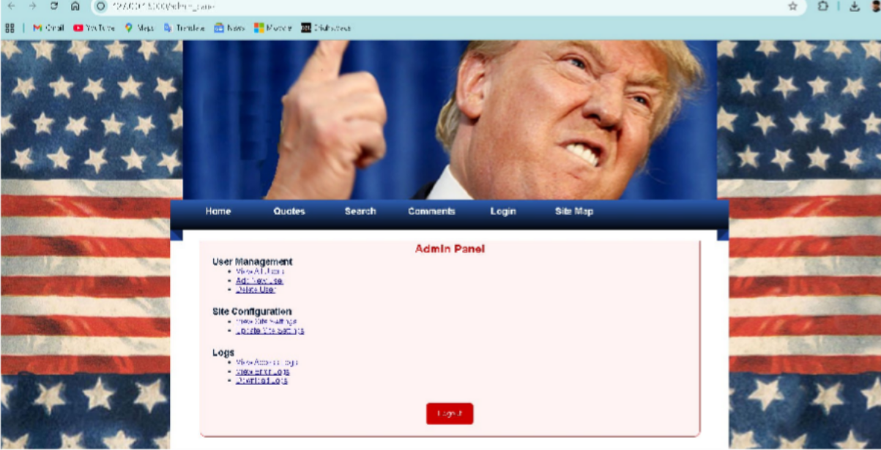

The backend has no authentication whatsoever, and who ever wants to access it is free to do so



To fix this, the code now has a key for the administrator, so if anybody was now able to try and login wihout the code it will now not be possible.

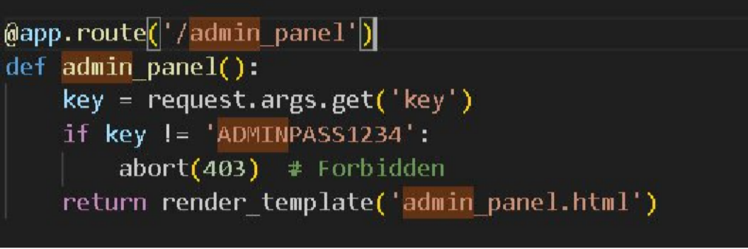

If we check now, the website does not allow access to the admin panel

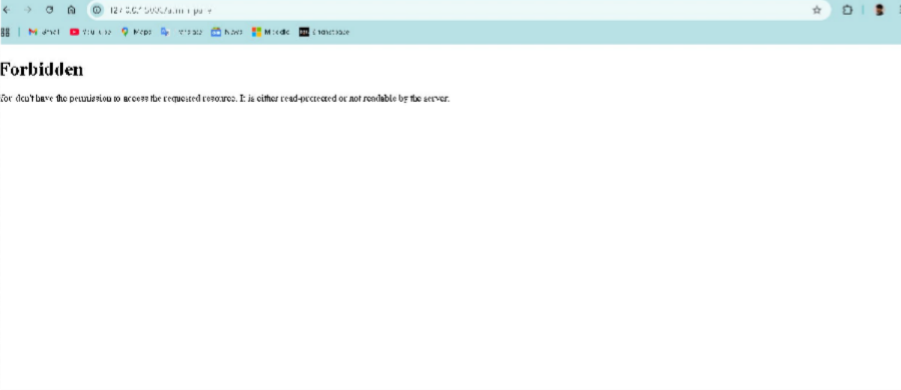

+3

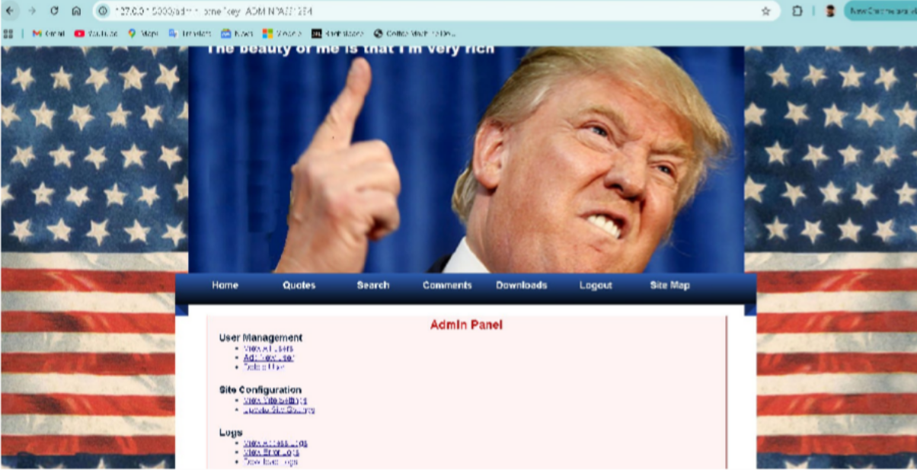However if we try with the key in the address bar

We now have access to the admin pane

Insecure Direct Object Reference vulnerability was found. To do this we first needed any login detail. since the website does not have a sign up option, ssing the sql file provided we got one login,

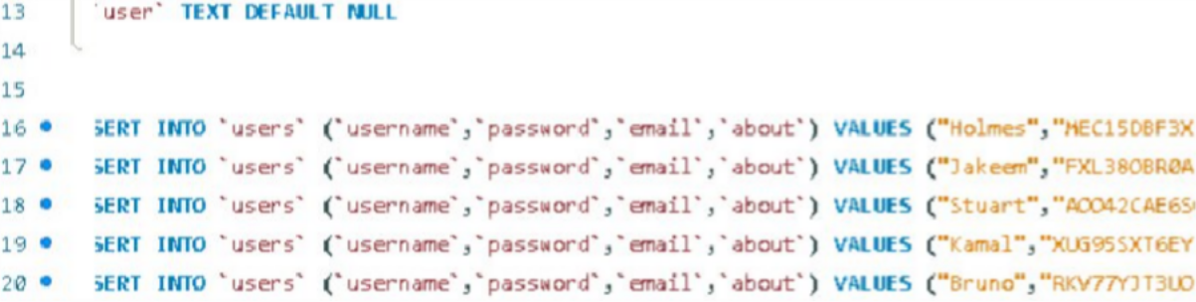I decided to use username ” Holmes” and his password “MEC15DBF3XD”in this isntance

Once I logged in this was the page I had access to:

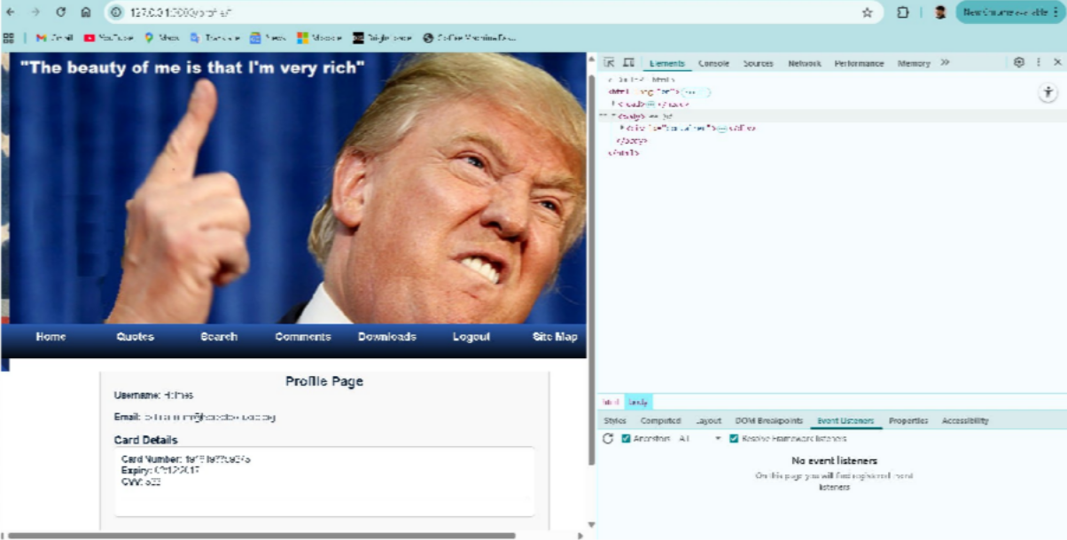

On this page in the url bar it shows us that profile id is 1, using this, we decided to change profile by changing the 1 to a 2 and refreshing the page.

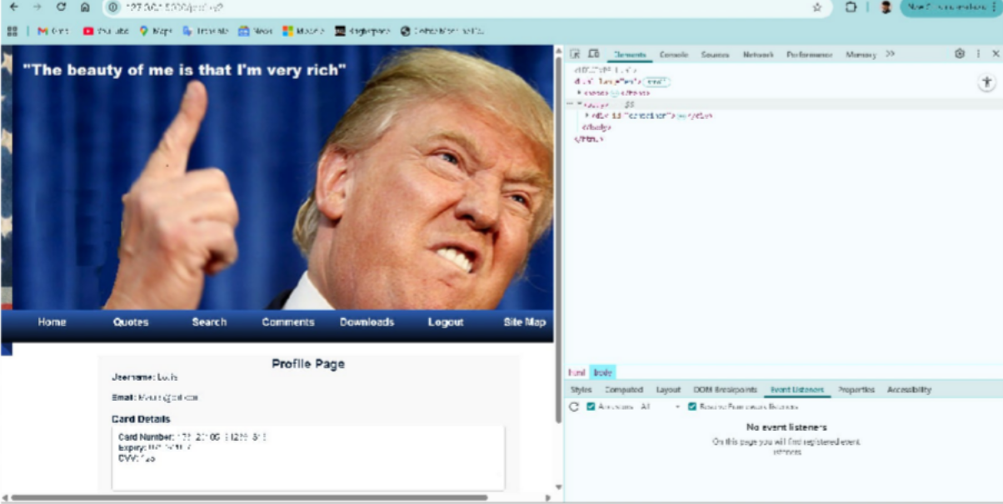

Just by doing that we had access to another users account this was beacuase of IDOR, the site only checked what the user asked for and it never checked wether the user was allowed to ask for it, ie no authorisation – code below is missing authorisation

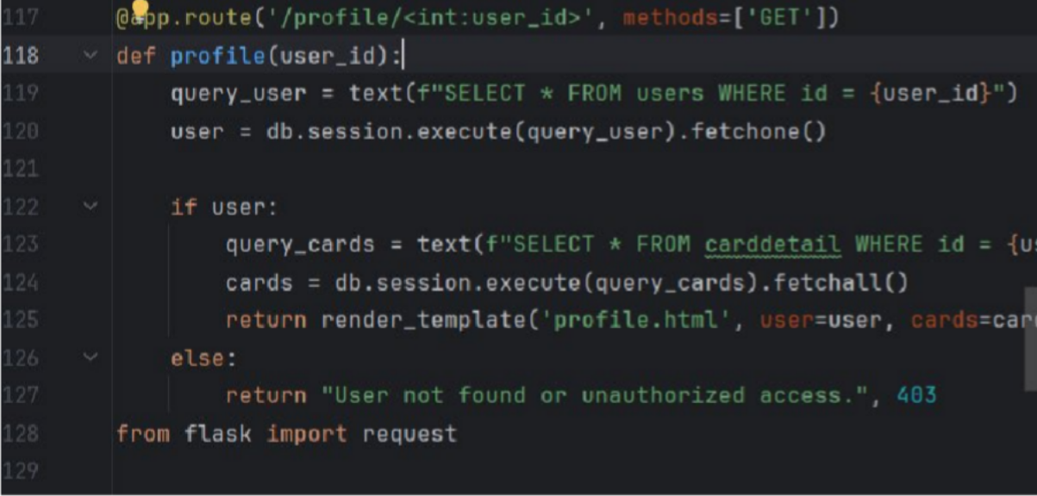

To allow for authorisation we have to add a line to the script if session.get("user_id") != user_id:

abort(403)

this compares the session ids and aborts if it is incorrect

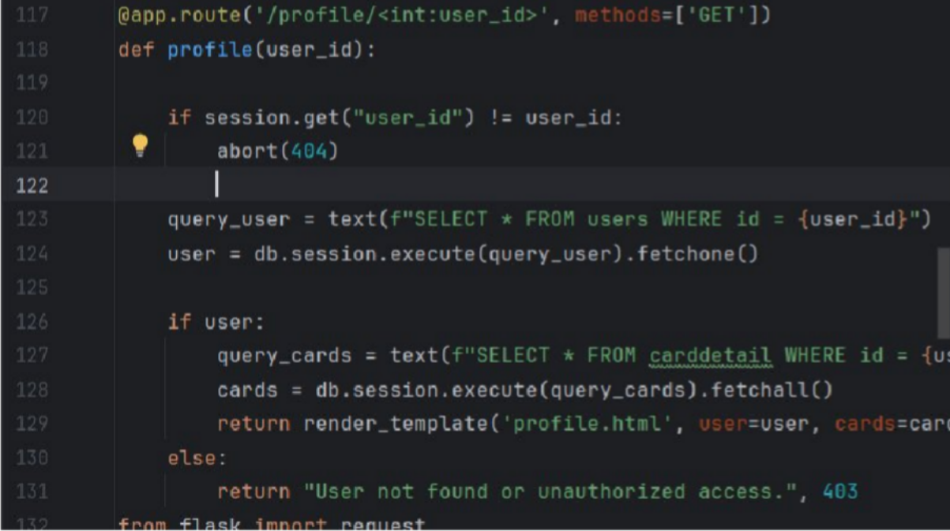

Now we can test to see if it works

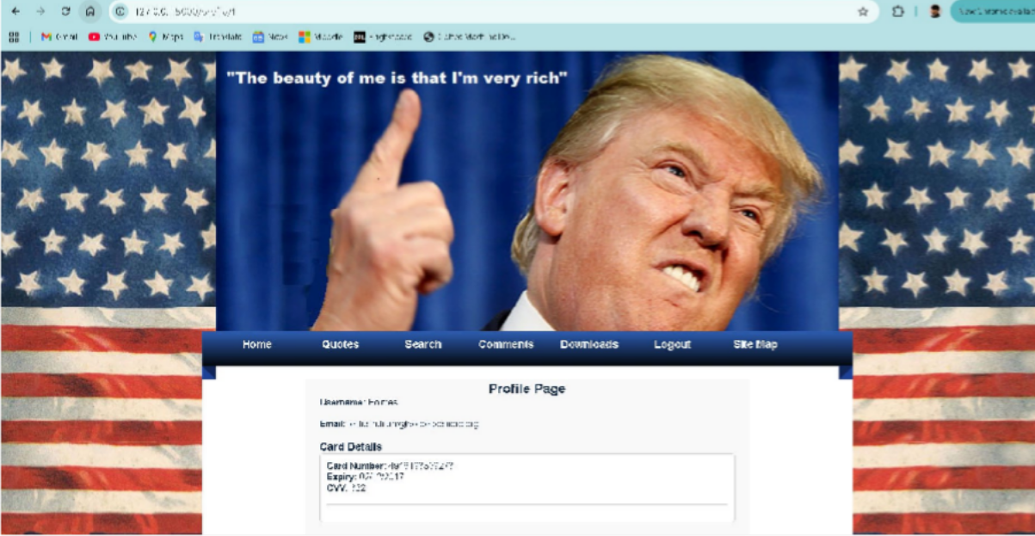

We are in profile 1, if we try change it to profile 2 like earlier:

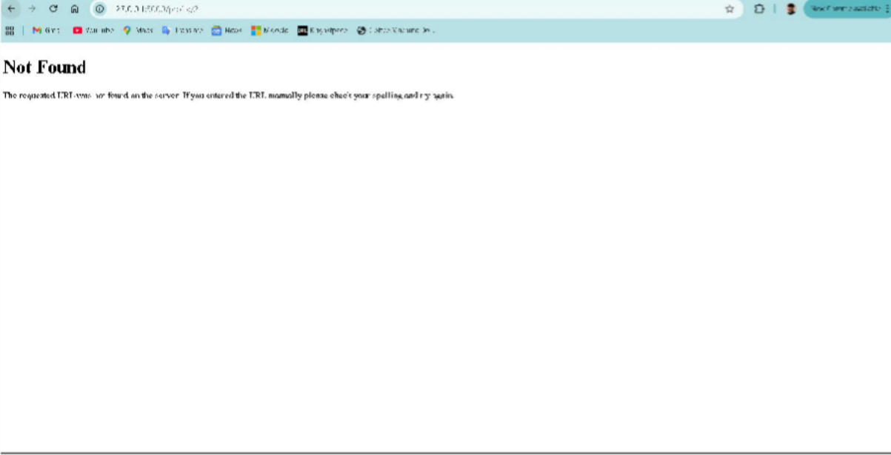

The System Aborts

An open redirect vulnerability was discovered within the sitemap of the page. The redirect element underneath(downloads/comments/quotes) allows for redirection of the webpage to an external source without any input validation

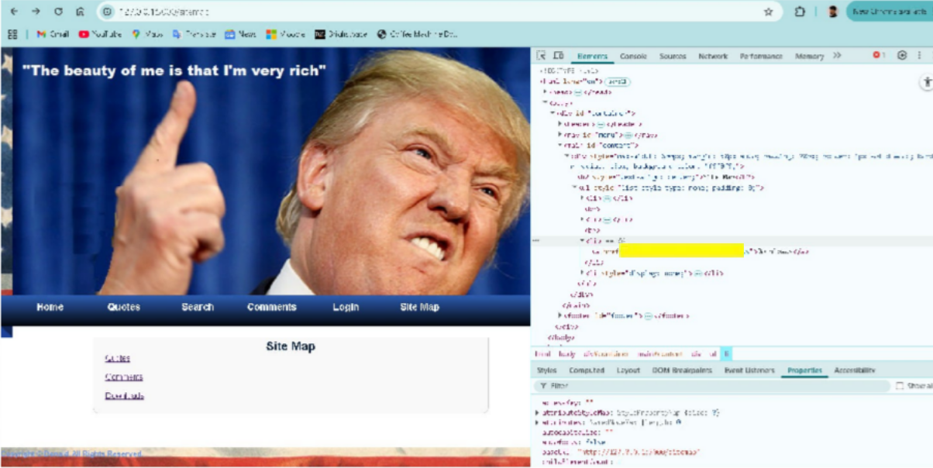

Same vulnerability was discovered in the url tab, allowing for a redirect into other websites without input validation

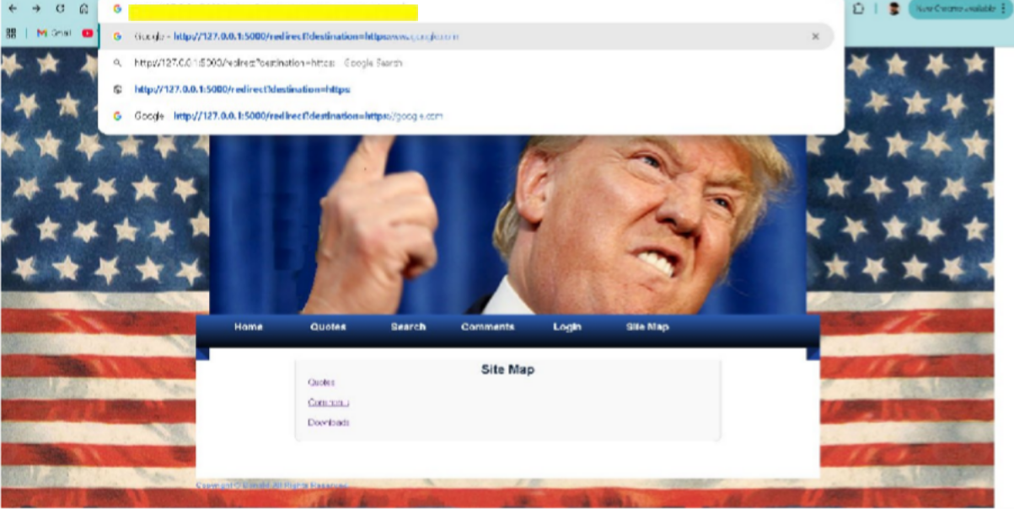

Both when clicked on or pressed enter redirected to google as shown below

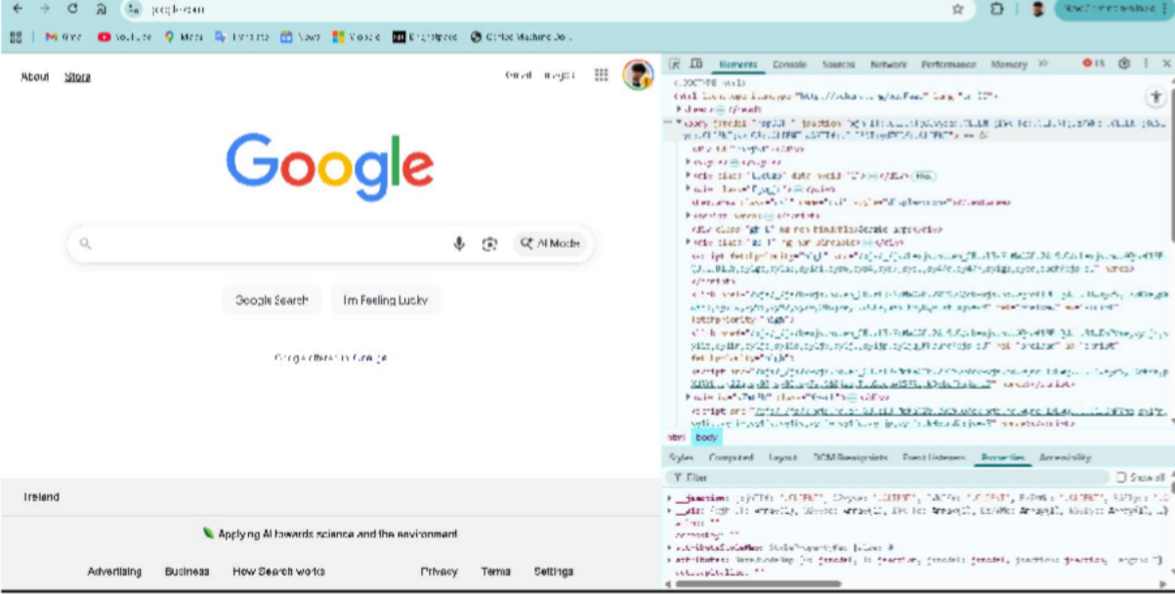

Problem in the code:

As you can see down below the code not check for any input validation and just redirects when asked

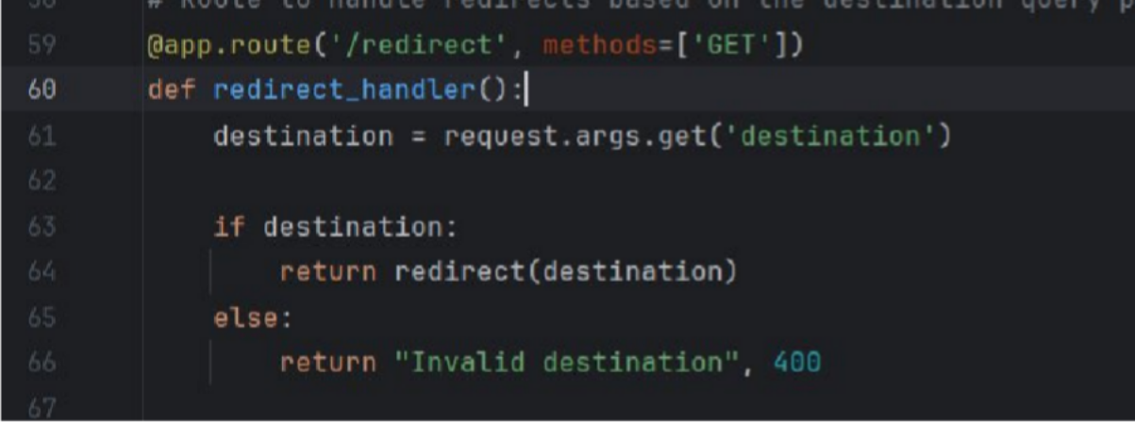

To fix this: we add a line in the code which only allows for redirection to happen if its within the website or followed by the ” / “sign

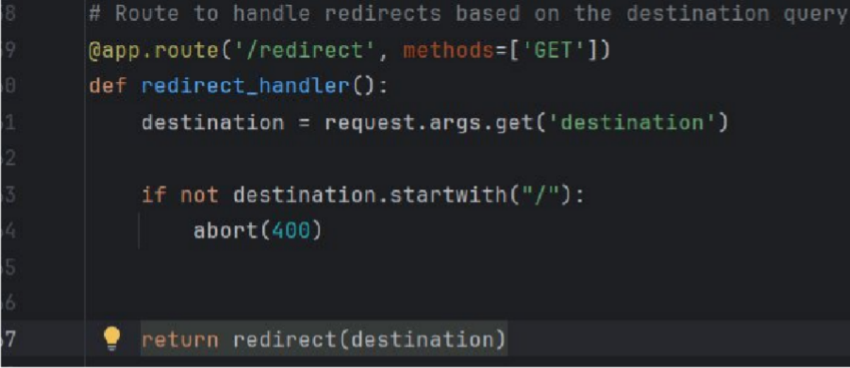

And finally to prevent the code from aborting when we click on the sitemap to downlaods, comments or quotes we have to go into html file for sitemap and then add a “/” before each of the locations

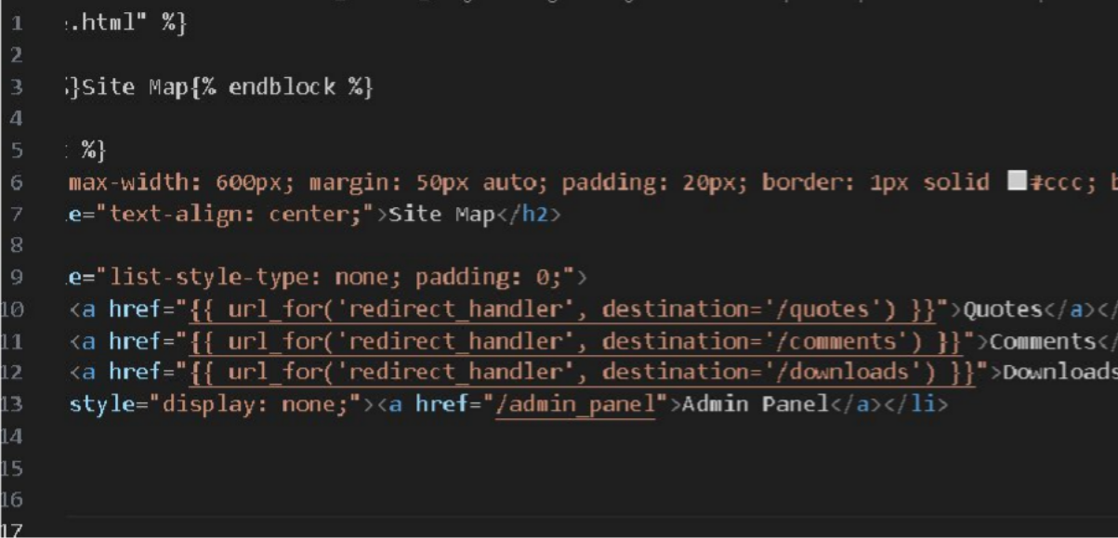

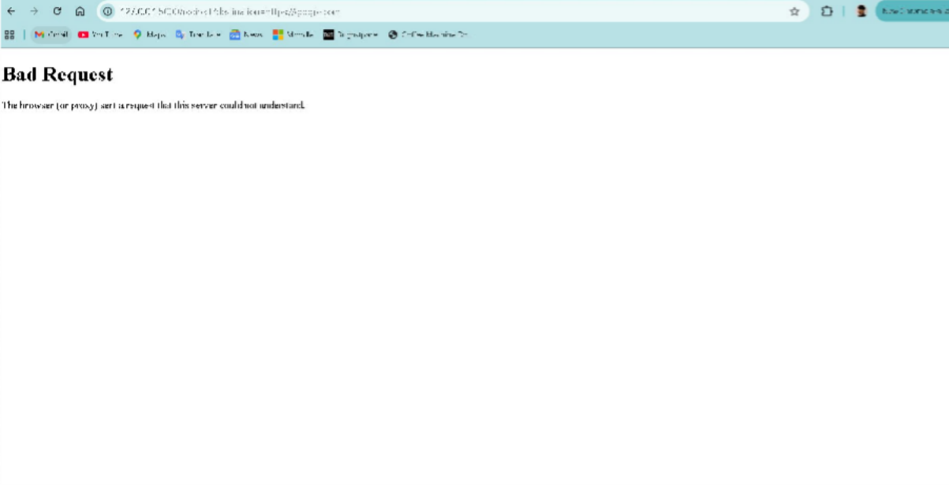And now when we try to execute open redirect this time it fails

PRANAV:

**Known**

**Stored XSS**

The site allows raw input for both username and comments. A malicious actor could add in code, for example a script tag, as either the username or comment. What this would do is when the comment is "published", another user who opens the comments section would "execute" this line of code, basically carrying out the code left by the attacker.

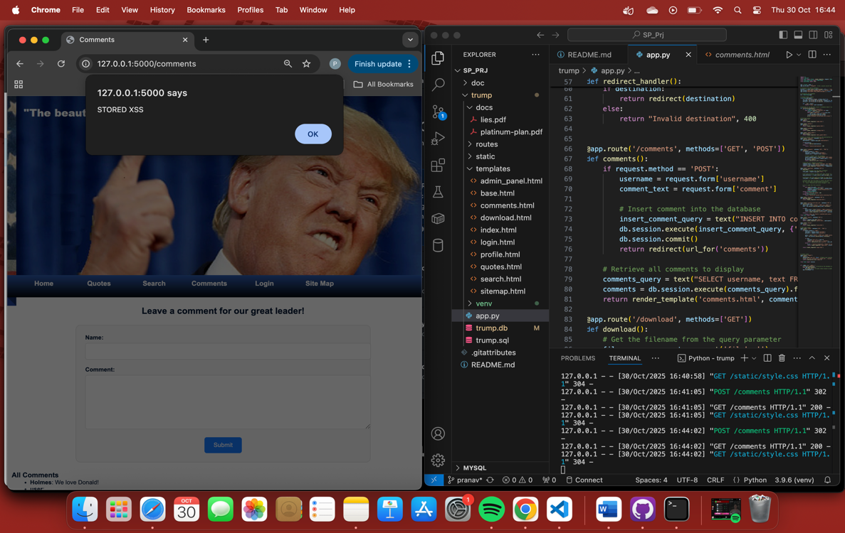

This is where the vulnerability in the code was spotted:

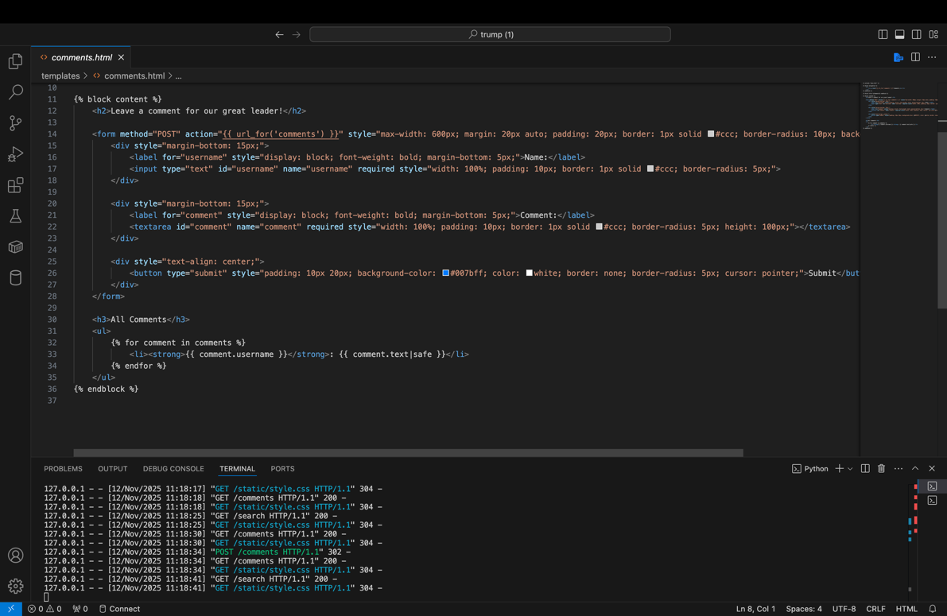

In this project the vulnerability could be exploited by a malicious user leaving a comment. This could happen either by adding the alert script in username field or as the actual comment. The site does not at present filter/sanitize user input. The {{ text.username | safe}} and {{ text.comment | safe}} means it is safe to "render" whatever is passed on.

This is the input form presented to the user:

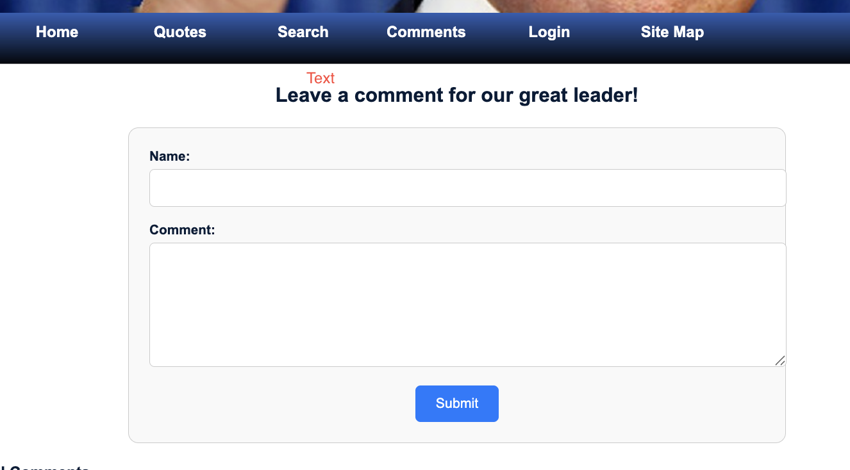

They attacker the adds the following script: `<script>alert('xss')</script>` into the input forms

This is solved by either sanitizing the user input or using the {{text.comment }} without |safe, which prevents the comment from being rendered as the intended.

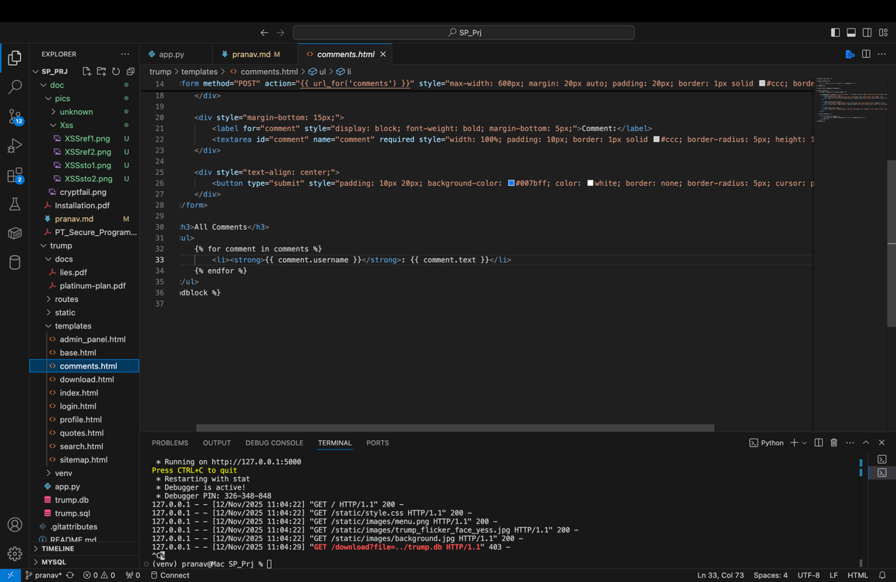

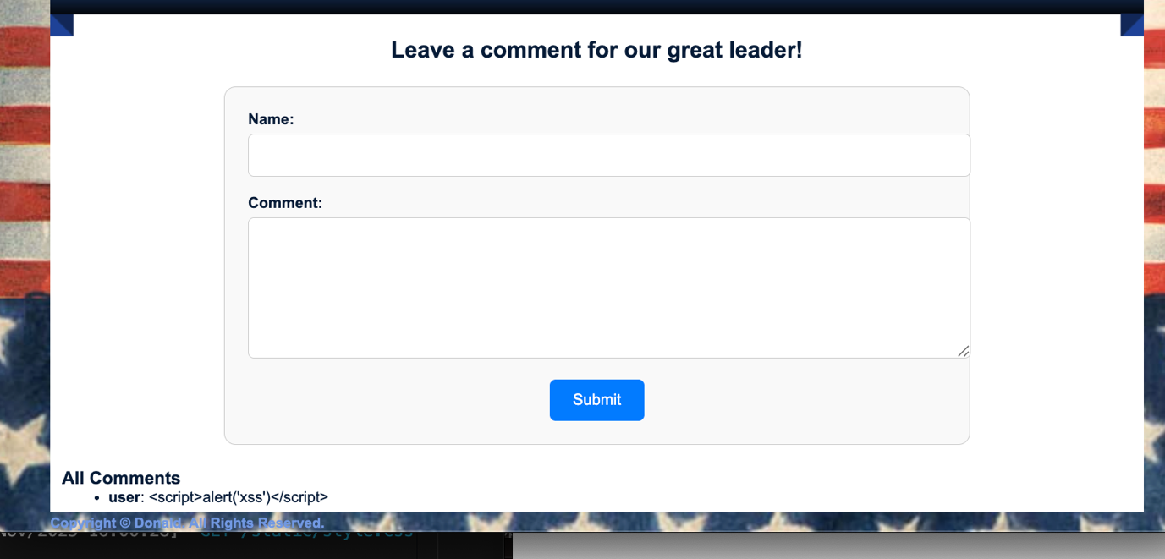

**## Reflected XSS**

The site allows for raw input into the search bar. This means a malicious actor could misuse the search function by inputting malicious code. They could gain unnecessary information like information regarding the server and use it later in a sophisticated attack.

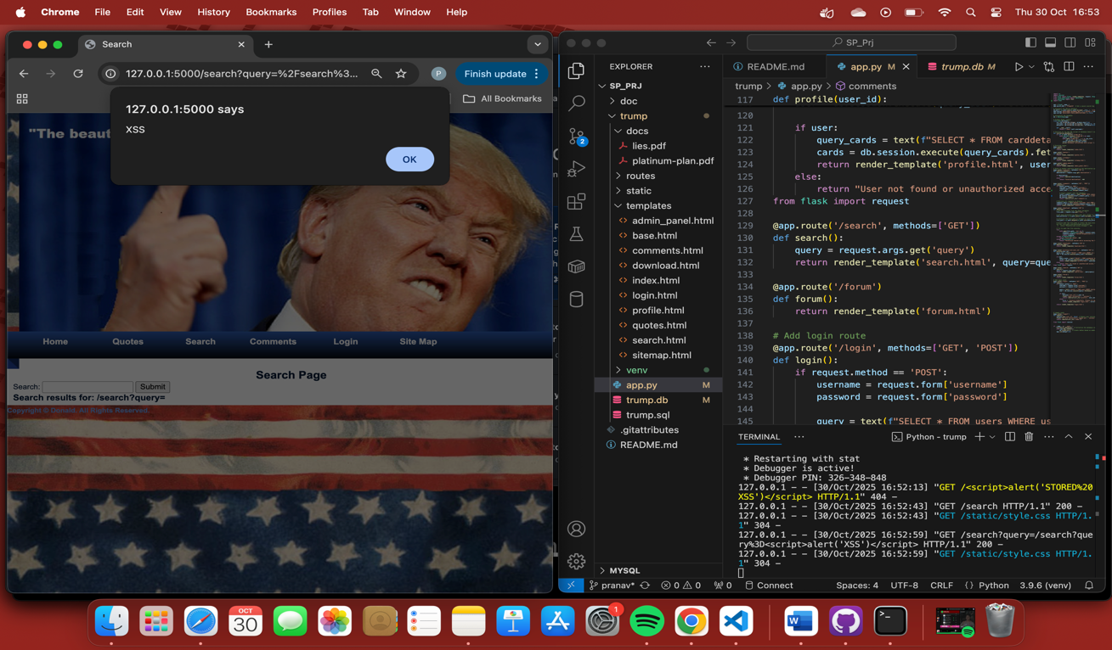

This is where the vulnerability in the code was spotted:

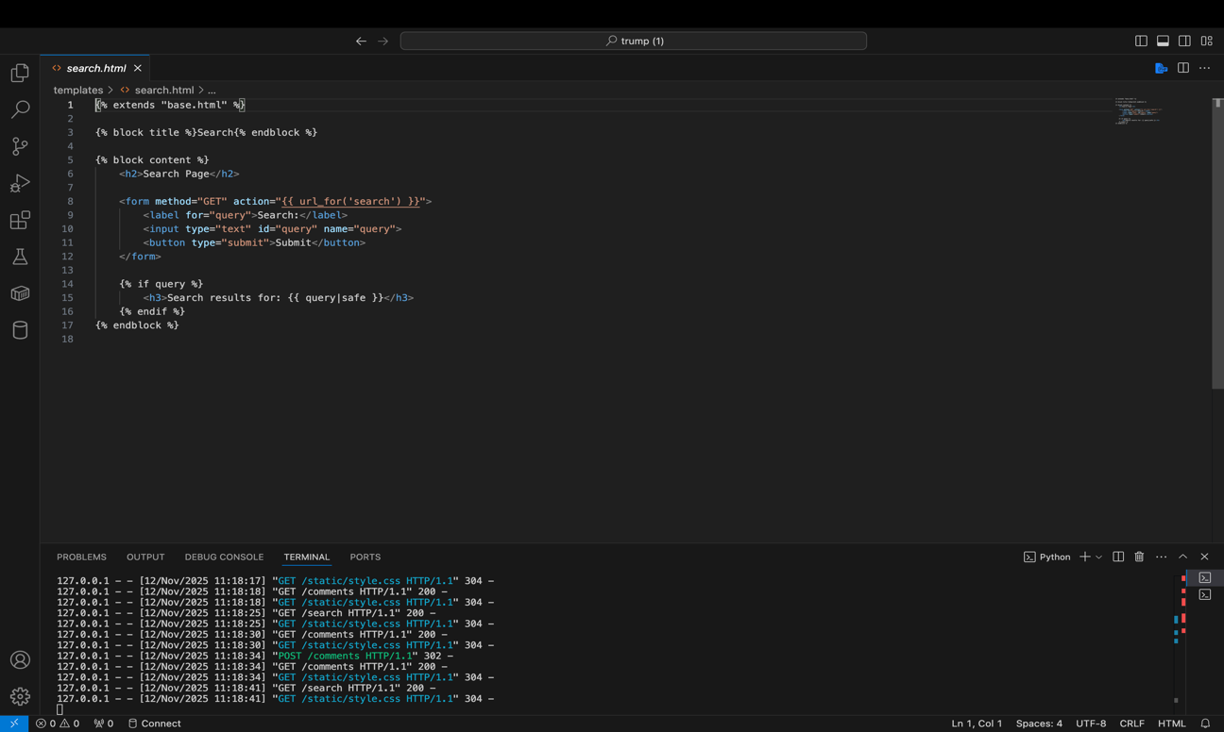

In this project the vulnerability is exploited by the user using the search bar. This attack can take place by "searching" a malicious line of code. The reason this works is because one again the site does not filter/sanitize user input. The `{{ query | safe}}`,(see above) means it is safe to "render" whatever is passed on.

They attacker the adds the following script: `<script>alert('xss')</script>` into the input form which causes the attack.

This is solved by either sanitizing the user input or using the `{{ query }}` without |safe, which prevents the comment from being rendered as the intended.

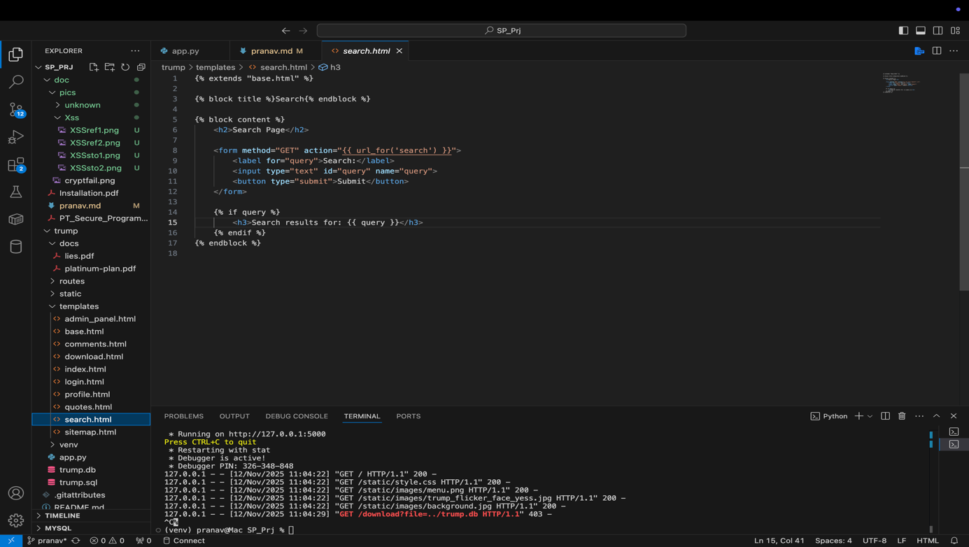

**## Path Traversal**

This site allowed the movement/traversal from one directory to another. This is a big vulnerability because a malicious user to navigate to beyond what the user is supposed to see. Malicious actors could traverse directories like this and download restricted files. Granted while they wouldn’t known the exact structure, they could still try multiple possibilities, taking advantage of common structures and directory names.

In this project, malicious actor can input into the search bar of the browser, as a suffix the following `/download?file=../trump.db`. As seen in the first screenshot, this enables the download of the entire database which is a major breach. This is because `.abspath()` converts a path into an absolute path without checking if it stays inside the directory

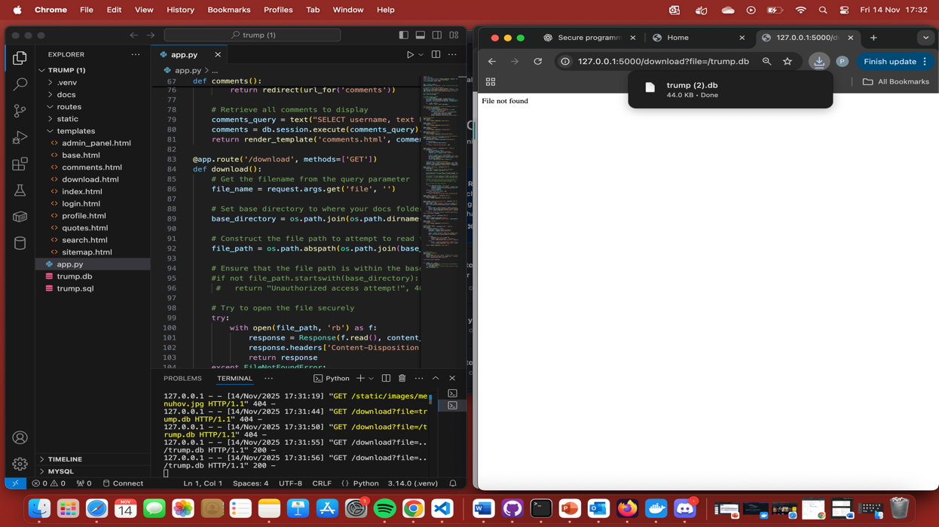

This is where the vulnerability in the code was spotted:

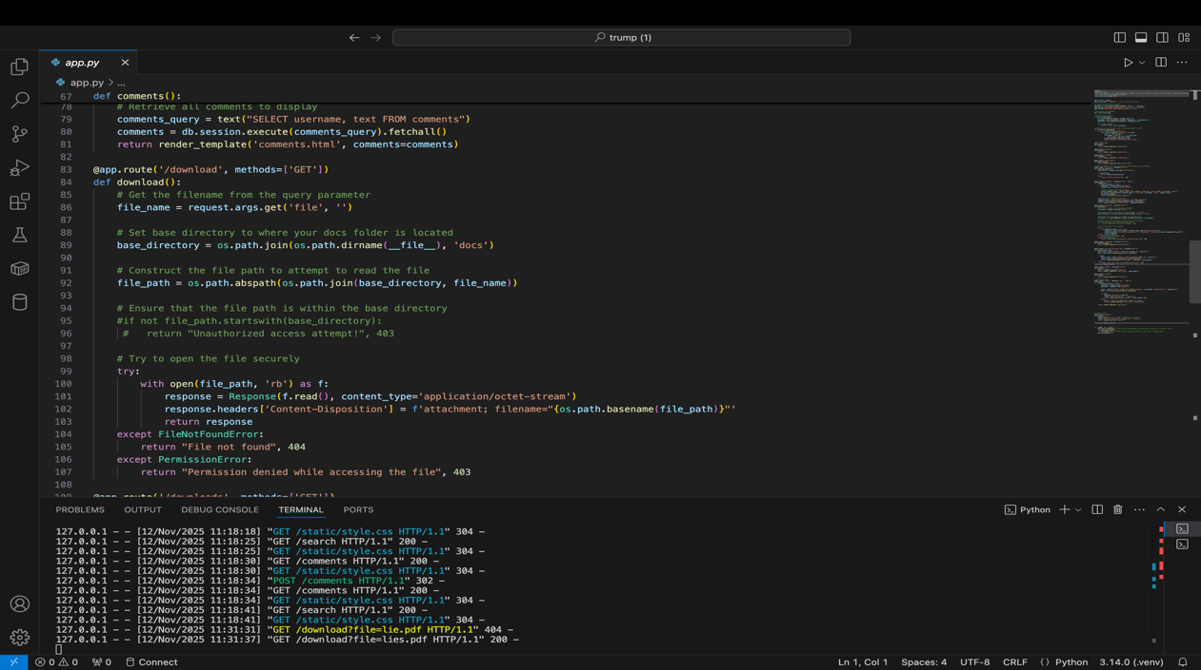

This was fixed by using `os.path.normpath` which ensures the path starts with the base directory preventing traversal.

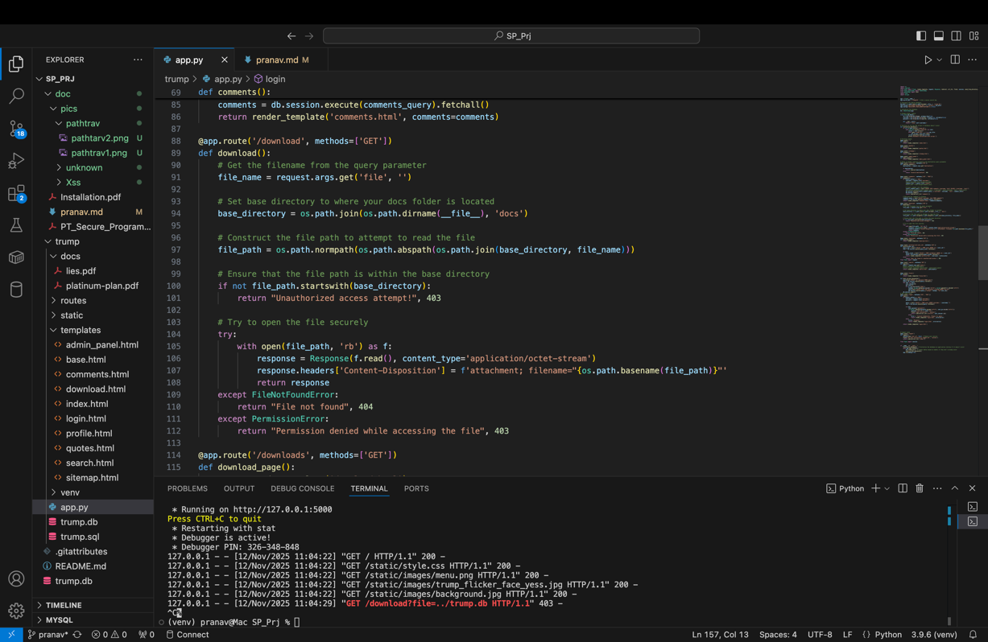

The exploit no longer works. Even if they user knew beforehand the exact file structure, using os.path.normpath` prevents any such attack:

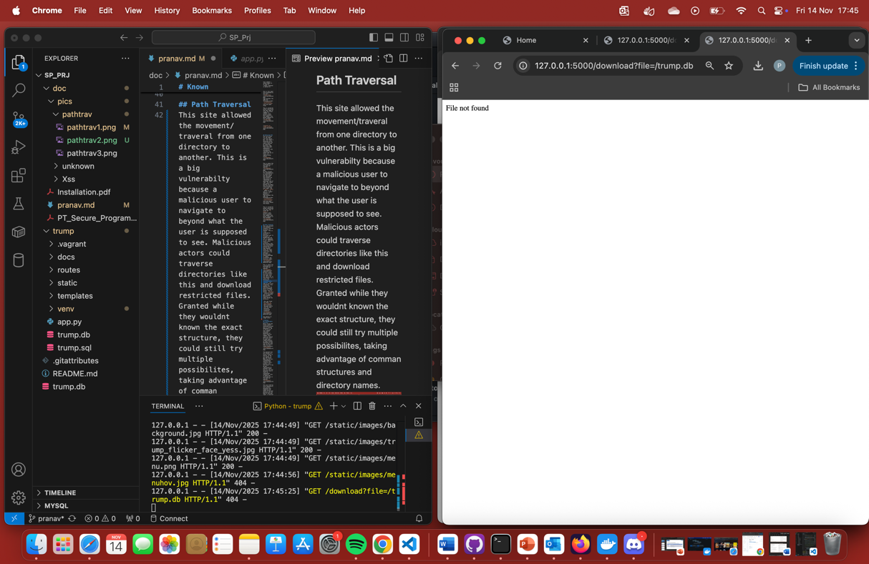

**# Unknown**

**## Cryptographic Failures**

While fixing the path traversal vulnerability was able to prevent download of .db, if the db was ever leaked, plaintext passwords of users would be leaked. This could be used by malicious users to used said leaked password on other account belonging to the user in the hope that the user reuses passwords. This exploit is done the same way as the path traversal exploit.

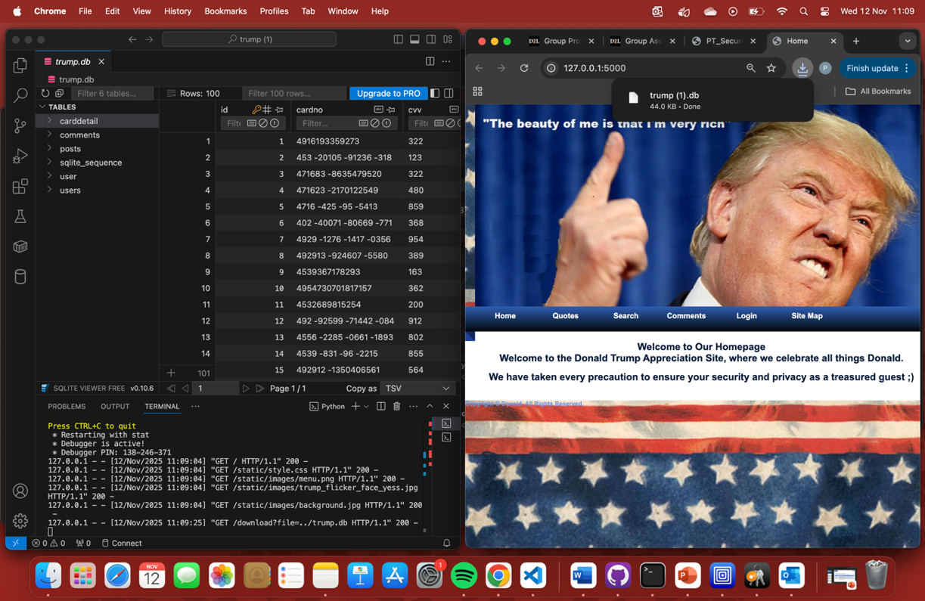

The password was not stored in a secure format in the db. It was not hashed. As per the lasts OWSP top 10 list, cryptographic failures were listed as the 2 highest risk. This means if the db was compromised an attacker would have all the user passwords and it could be interpreted immediately. This is where the vulnerability was spotted:

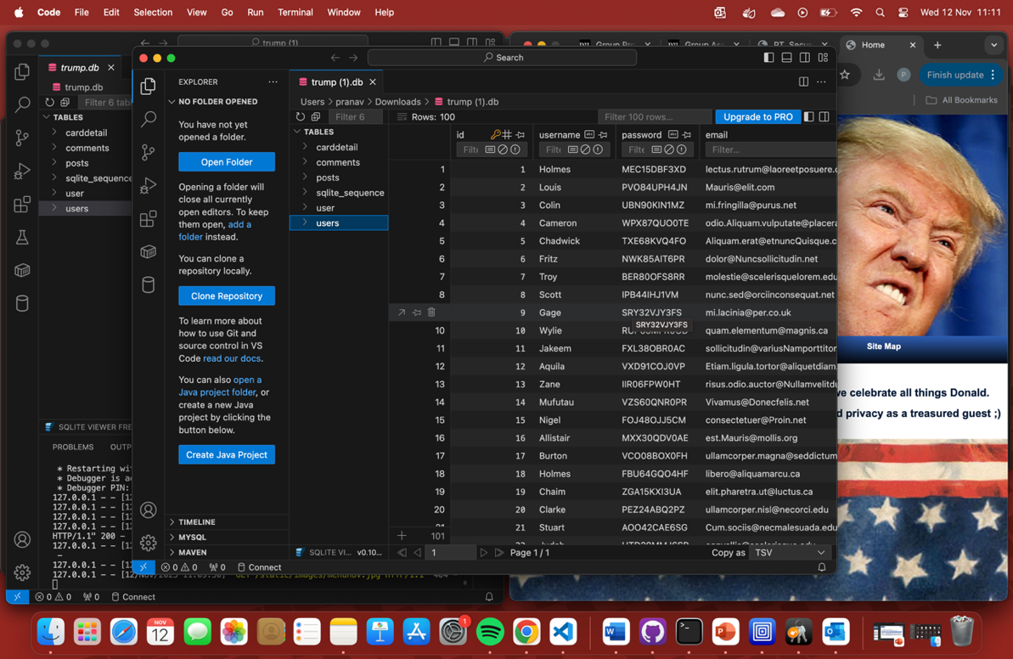

This was fixed by first hashing all the previous passwords and comparing the hashes of the user password and the hash of the user input. A function(see below), to carry out previously entered unhashed passwords was made and "called" every time at the "start":

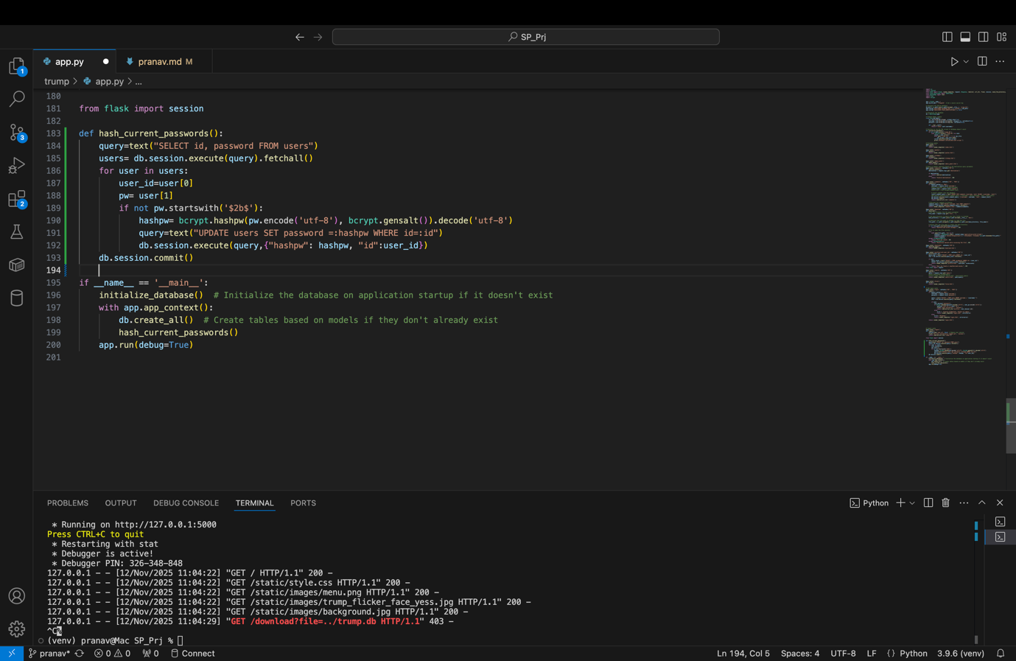

The `hash_current_passwords()` functions connects to the db and hashes all the passwords. It is called inside:

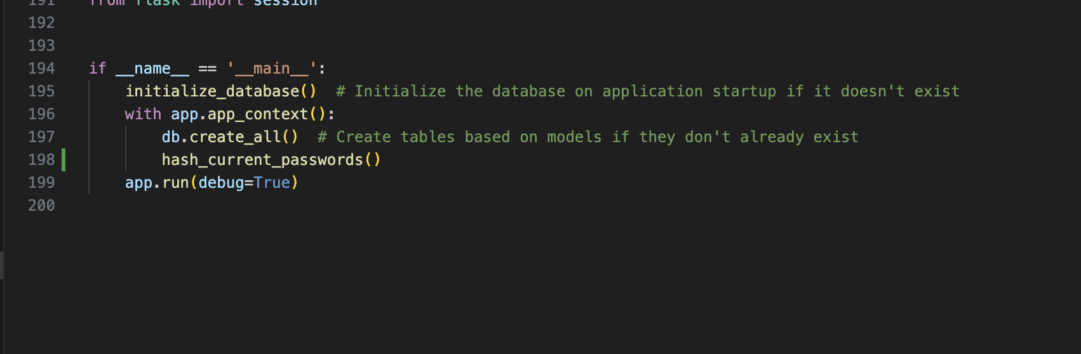

immediately after the db is created. This is a “shortcut”.

And an updated login to compare hashes and not decrypted passwords. In the pic below we are comparing hashes as that is the best practise. Rather than decrypting user inputted password and password in db and comparing, below we check the hash of the user inputted password and password in db. The `checkpw()` function below(line179) hashes the input password and checks it with the hashed password in the db:

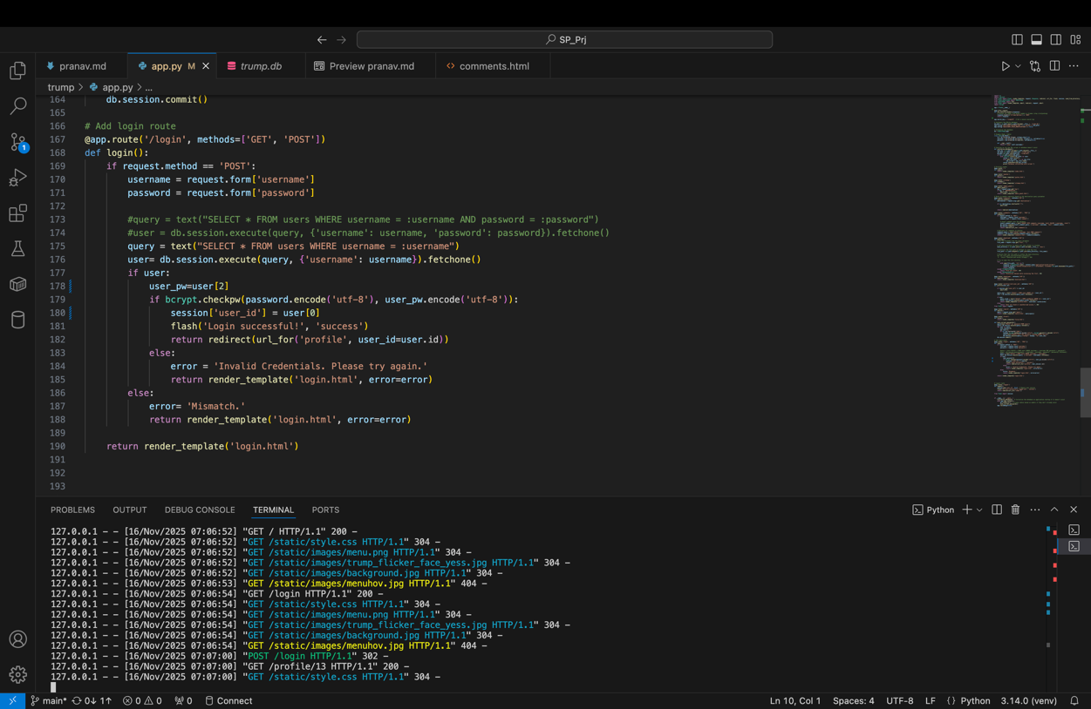

Here is what the db would look like if the hacker still managed to access it:

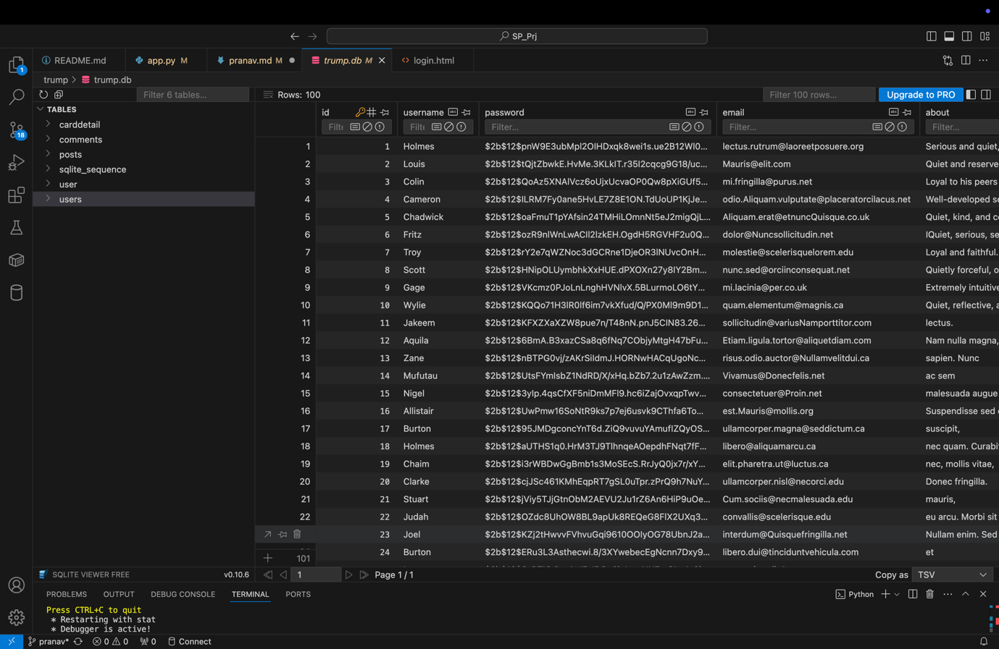

Even if they are able to obtain the hashes, as you can see its harder and more time consuming for them to reuse to password for the users other accounts. It is always better than having access to the plaintext password

OJAL

Errors i found looking at [app.py](http://app.py) code

Im using owasp zap to find vulnerabilities.

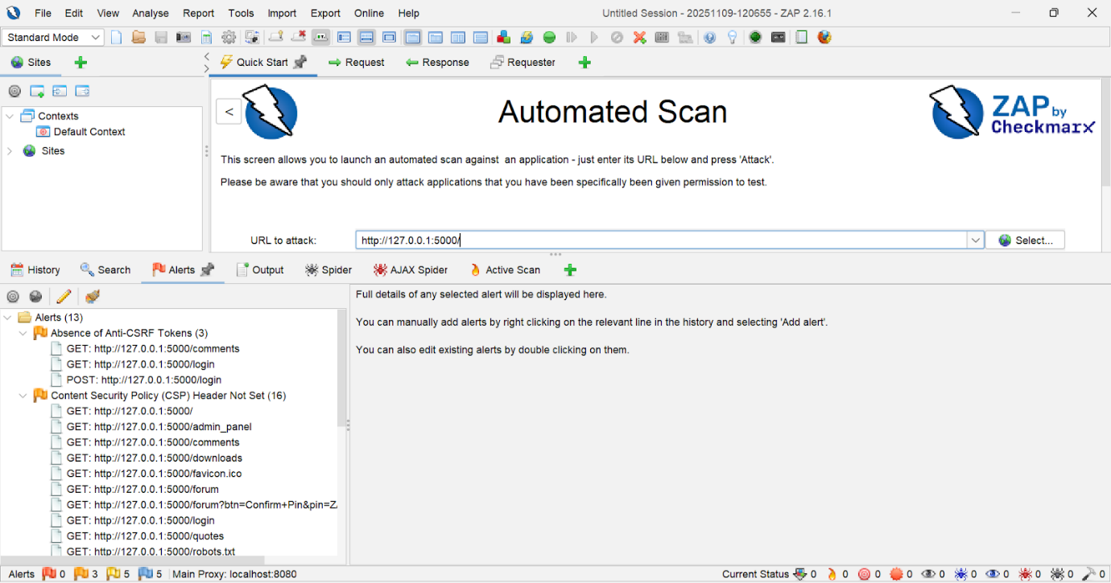

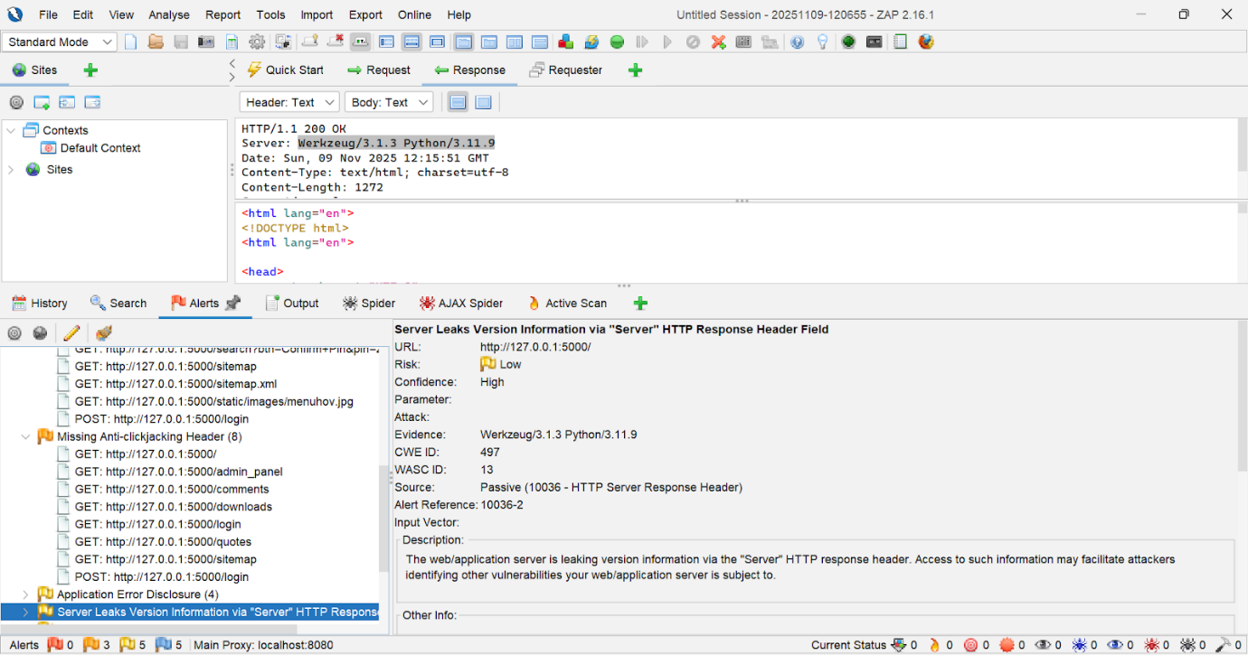

Known Vulnerability:

1. **Login route — raw SQL with user input, space for sql injection**

//reference: [SQL Injection Prevention - OWASP Cheat Sheet Series](https://cheatsheetseries.owasp.org/cheatsheets/SQL_Injection_Prevention_Cheat_Sheet.html)

Sql injection used : ' OR '1'='1

Faulty code and why:

query = text(f"SELECT * FROM users WHERE username = '{username}' AND password = '{password}'")

Why this is risky:

* Attackers were able to insert SQL commands into the username or password fields because user input was dropped directly into the SQL command.
* This allows hacker to change the trump database's functionality like avoiding the password check and logging in under a different identity.
* They can read private information (emails, profiles) if they can log in or run queries.
* also, they might alter or remove data (erase records or break the app).
* It relied on insecure password handling and exposed more data than necessary due to the use of SELECT * and plaintext password checks.

What I fixed it into

query = text("SELECT * FROM users WHERE username = :username AND password = :password")

user = db.session.execute(query, {'username': username, 'password': password}).fetchone()

Why its safer:

* The code i added instead uses parameterisized queries (placeholders) so the database treats username/password as data, not code.
* That prevents user input from changing the SQL structure
* I’m no longer building the SQL string by hand, which removes the easy injection vector.
* The fixed code is also clearer and less error-prone cos it’s harder to accidentally introduce another injection later.

Result of sql injection done in comments page:

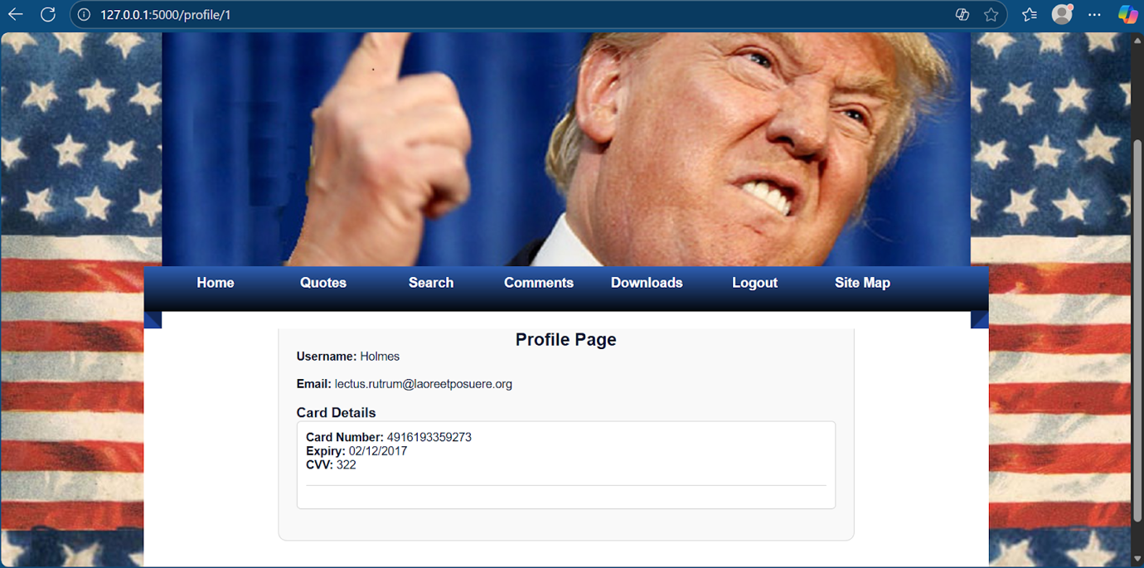

Unknown Vulnerability:

1. **Clickjacking -**

tricking a user into clicking something on a hidden or framed page by placing a fake UI over it, so the user thinks they clicked the attacker’s button but actually clicked a button on the Trump site.

Example scenario:

* Trump site has a “Delete account” button and you’re logged in.
* Attacker(Me) page places a big, shiny “Click me!” button over the framed “Delete account” button.
* usernclick the shiny button but the browser delivered the click into the victim iframe and your account gets deleted!!

First and foremost I made this basic html attacker page with our website embedded into it

Reference :[<iframe>: The Inline Frame element - HTML | MDN](https://developer.mozilla.org/en-US/docs/Web/HTML/Reference/Elements/iframe)

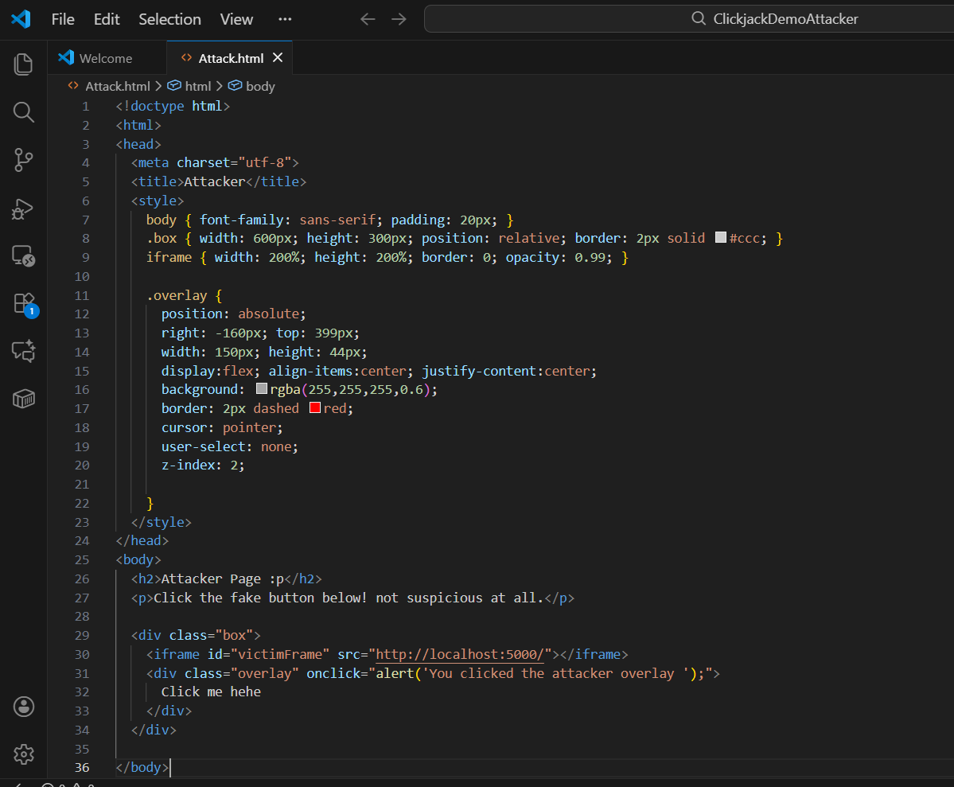

And upon running it on a different server it looks like this

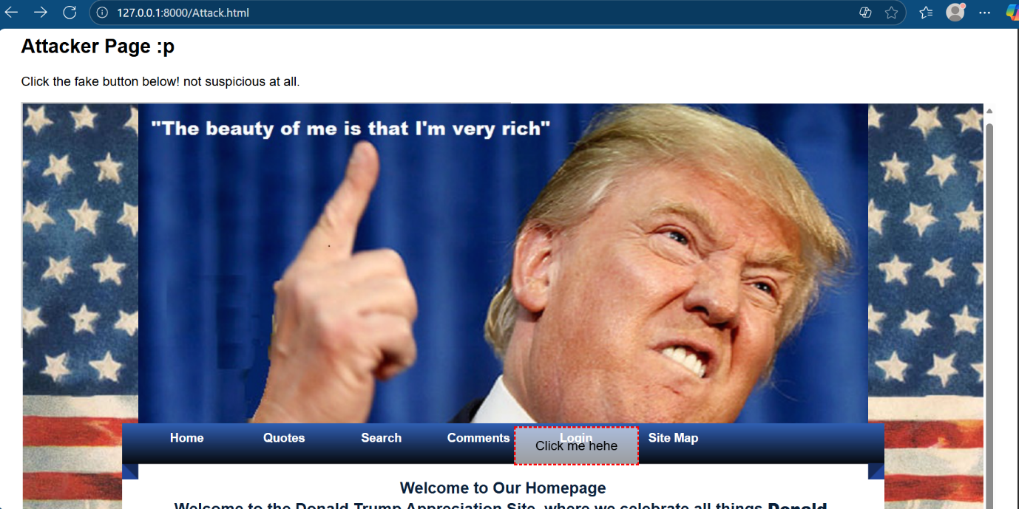

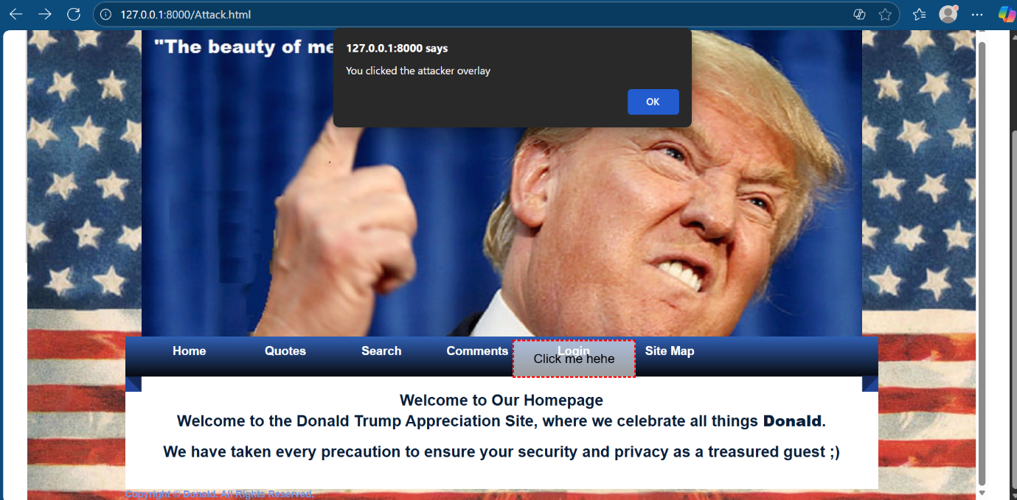

And so obviously we can see thus website is susceptible to clickjacking attacks.

My fix:

Just above  app = Flask(__name__) I added the code below

References :

[X-Frame-Options header - HTTP | MDN](https://developer.mozilla.org/en-US/docs/Web/HTTP/Reference/Headers/X-Frame-Options)

@app.after_request

def set_security_headers(response):

    # Prevent our pages from being loaded in iframes (stop clickjacking)

    response.headers['X-Frame-Options'] = 'DENY'

    return response

* Prevents the app’s pages from being loaded inside <iframe> or other frame elements.
* This stops clickjacking attacks, where a malicious page tricks a user into clicking hidden elements on our site.

How it works:

* Adds the 'X-Frame-Options: DENY' header to every HTTP response.
* Browsers enforce this by refusing to render or embed the page in any frame.

Why it’s safe:

* Does not execute any user input or external code .
* Applies globally to all routes via @app.after_request.
* Only modifies headers so no impact on legitimate user interactions.

After the fix:

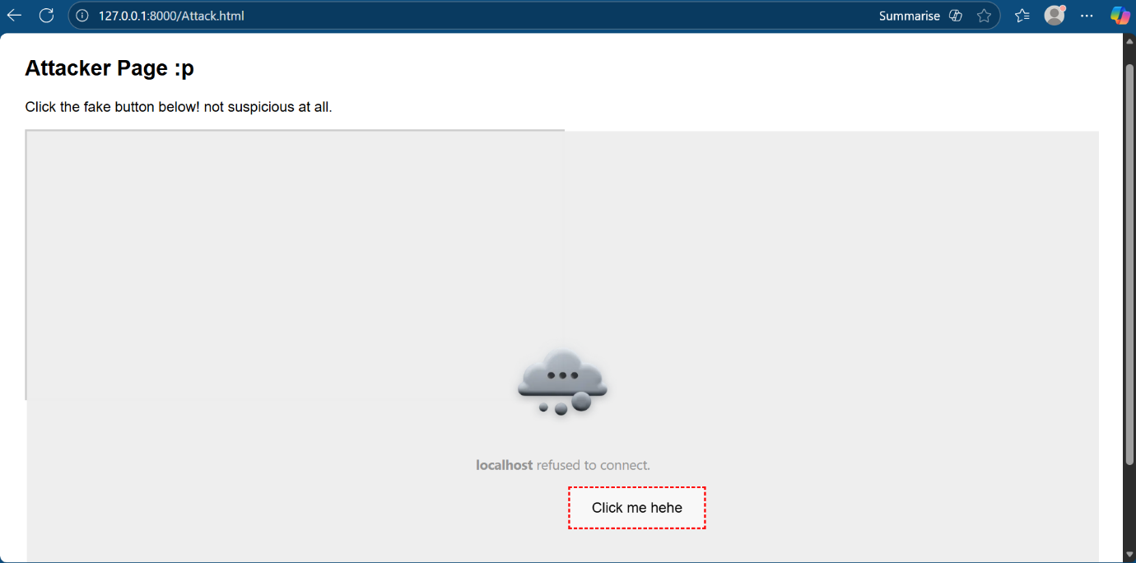

1. **Debug Mode Exposure(RCE) –**

What it is: The website was running in Flask’s debug mode. This turns on a built-in web console that lets anyone run Python code on the server. In other words debug mode accidentally gives visitors a web-based Python terminal. They can use it to read files, run commands, and take over the server.

Where the flawed code is:

Its right at the bottom

if __name__ == '__main__':

    initialize_database()  # Initialize the database on application startup if it doesn't exist

    with app.app_context():

        db.create_all()  # Create tables based on models if they don't already exist

    app.run(debug=True)

What I did to expose it:

Just after my url, I typed console to pull up the console. Although it requires a pin, a console should never show up on a deployed app. Anyone can brute force a pin and further have access to sensitive data like the db.

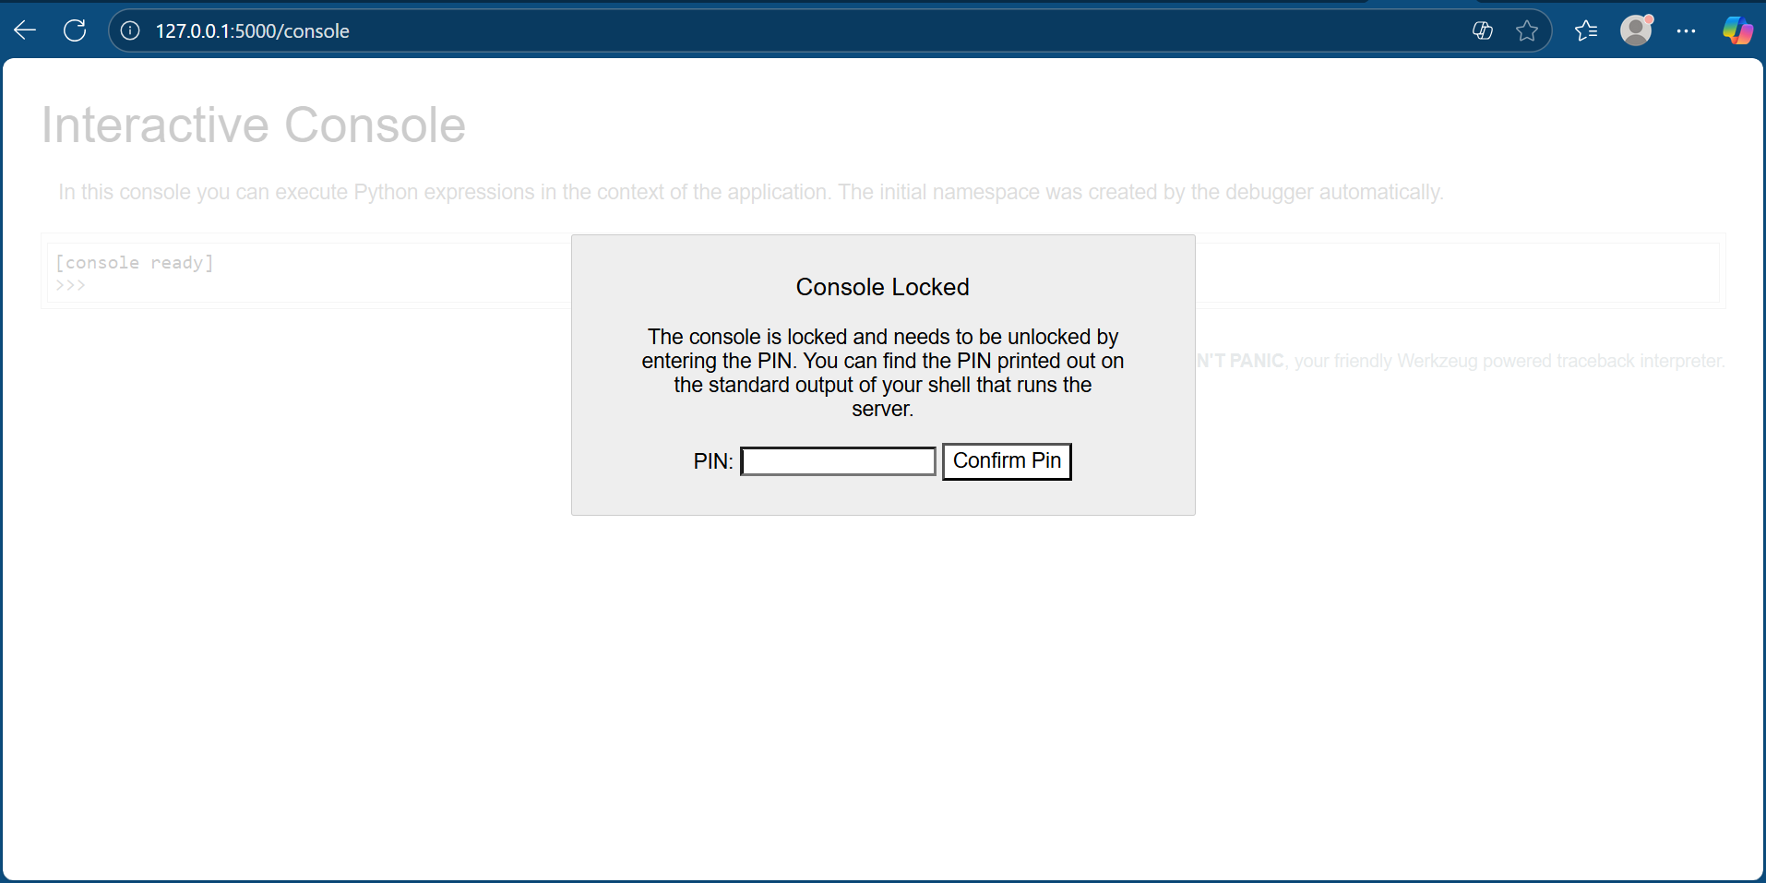

To fix this, I simply turn the debug setting to false instead of true.

app.run(debug=False)

After doing this, if I try go in and access console again, the page returns a 404.

